Problems with the web page added to the Research tab in the Binder
I created a Novel project and then clicked on the plus sign icon Research in the Binder and then added a Web page. The page loaded poorly but you had it noted that it could be a problem. So I grabbed a different page, a Wiki page and it loaded great. But the right click links except for the copy link and copy image. The Open Link, Open in New Window, Save Link, Open Image, and Save Image do not work.
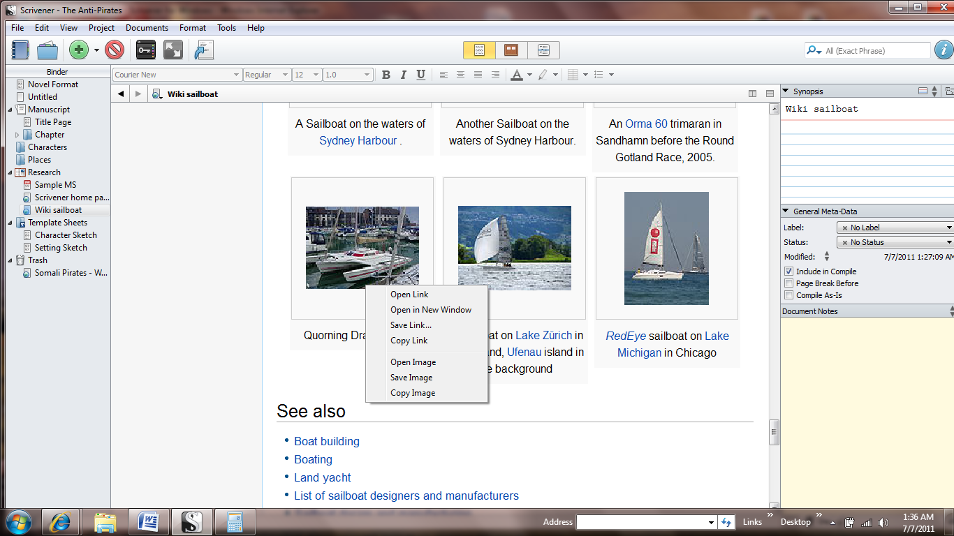
The Reload button works great.

